RECRUITMENT Management System
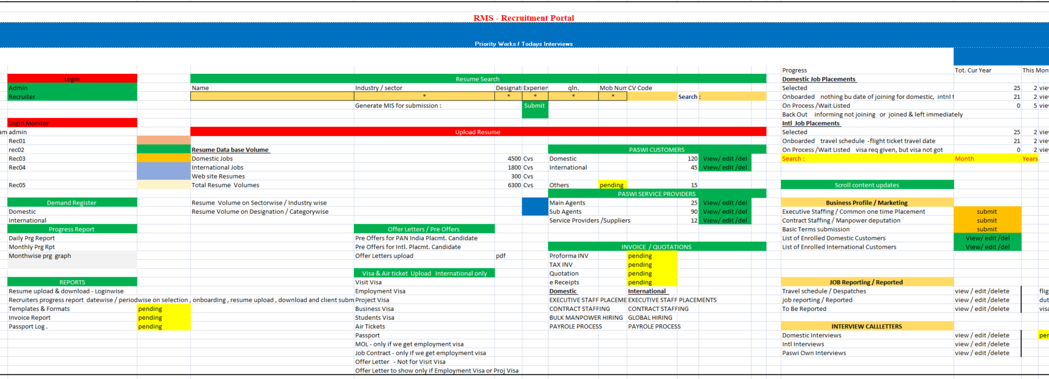

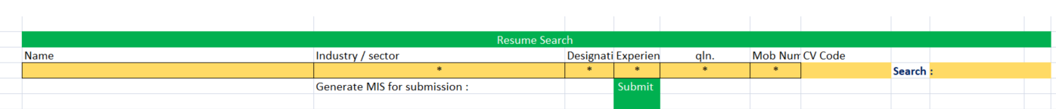
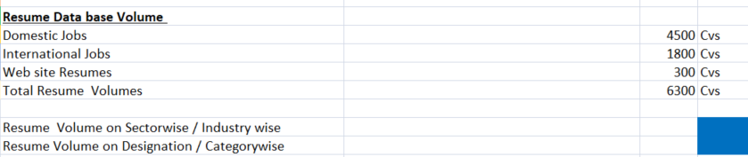

Emp-id | Auto Generated
First Name: |  | lastname
Code No |  | Date of Submission
DOB: |  | automatically Age will display
Email |  | Contact Number
Designation |  | Sector
Qualification |  | Industry
Total Experience |  | Placement Type
Post & Location Applied |  | Current Stay
CTC & Notice Period |  | User Type
Resume |  | Remarks

PLACEMENT TYPE | Industry | Sectors
EXECUTIVE STAFF PLACEMENTS | Manufacture | Oil gas / PCM
PROJECT WORK FORCE | Construction | Power plants
CONTRACT STAFFING | Engg. & Projects | Cement Plants
BULK MANPOWER HIRING | Maintenance | Textile industries
PAYROLE PROCESS | Operation, Testing & commissioning | Road & Fridge
 | Hotels | Civil Building Constructions
 | Hospitals | Automobile
 | Others | Locomotive Sector
 |  | Marine & Shipping
 |  | Miing Sector
 |  | Transport & logistics
 |  | IT Sector
 |  | Others

